Shadow Planets[sunshine out]

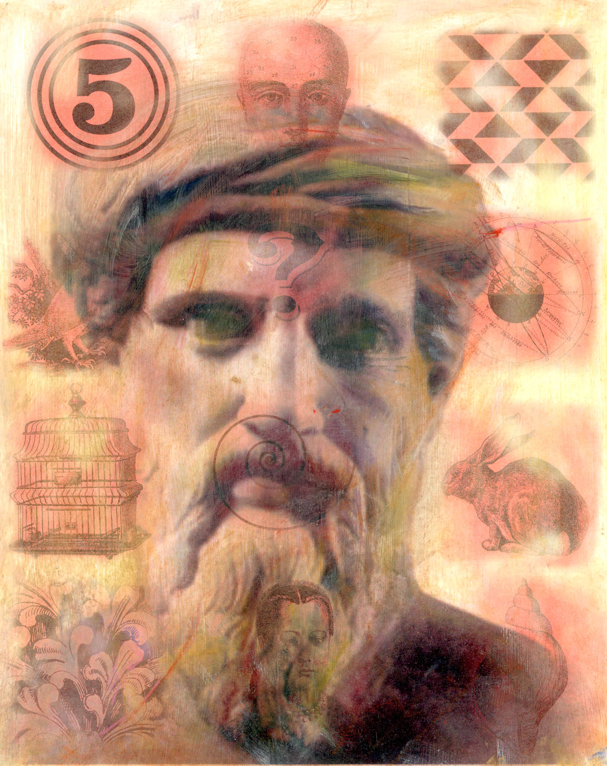

“On Genetic Variations in Mean Body-Mass and Base Metabolism in Anthropomorphic Representations of Abstract Concepts, or: hunger and thirst”

Thought is fat, complacent—full of
sweets to feed its girth. Whereas

Poetry

is hunger: it
does, it
moves, it al-
ways burns—

in search
of half-
chewed
energy
globules,
glutinous
crumbs
of matter—

Thought has power: it takes the fuel
of caloric fire and assimilates its sub-
stance, making it like itself to trans-
form the burning stars of the world to
fleshy tombs of cellulite—a power to
hoard and never combust, to lock in
entropic stores of deposits around the
hip and thigh.

Poetry

starves but
eats, keeps
no thing, al-
ways lacks
but always
burns

through the
crumb the
moment
it enters the
mouth—

a Poem

is more
likely to
waste a-
way and
die with
filthy
chunks of
matter, micro-
scopic fecal
specules caught
in cracked black
nails: with each

crumb like meta-
bolic lightning
flashing across
the sky as fire:
food to fist to
mouth to song:

In the end,

Thought is doomed to win and devour all
thin sustenance for which Poetry so
struggles, and yet—Thought begins as a
Poem that learns: whose skill in finding
the crumb it
needs be-
comes the
weight that
crushes.

*

ii.

the red rain rains readily.
Readily raining into the ruddy rains.
Ruddily red rain rains into the raw, raw red of Spain.

I rage at the rain.

5/5/08

The sad-tragic thing about writing is I don’t know how to do it. For the first time in my life I feel the fear. Sit down look at the page the cold blank page that’s nothing. Sit down, feel blank blindspot behind mind in down below mind in gut that’s where the writing comes from but it’s blinking, little caution light little check engine light on the dash beep-beeping from my gut.

There’s the Terror in the walls. Nothing to do but sit down face the gut-sick rustiness of lack of practice and unflexed spiritual expansion muscles and bite the ridiculous silly bullet until the wind comes back out of my mouth. Nothing to do but keep moving in the awful awkwardness body-consciousness of new writing, of writing after long escape.
Writing only comes in a flow. You know when you sit still and that terror cockroach rummages around in yr gut y’r on the wrong track. You know when you have to paw around that gutter mind for some filthy coin that appropriate word y’r off the narrow way, y’r down down in the broad wide paths of words, when writing in fact has little to do with sentences or phrasing or words or a quarter.

Writing is more like a movement. One thought leads to the next with a necessary pendulum-like appropriateness that follows, one on one to the moon – which is where all writing ends.
Seperateness – jewel-eyed mind center memory-object let it unfold there for you, lose yrself in the object.

Yeah yeah – it’s not that writing is a talent, or that it has anything to do with words. The sad-sick thing about not writing is that it’s not yr words that get sick and stale but yr little scrap of song that’s all you have on the planet – that little scrap of song yr soul. And writing is soul-expansion, feeling out of soul / feeling out for besides-itself.

There is one thing I want, though. I want the words to be practiced and sharpened and true – because I have a desire, a method-desire I’d like to be fit for, to put Kerouac and Isaiah together, and I can’t even express it words so worn and vacuous and silly.

If I could write one word, one word that’s really real. Sad sick delirium tremens of the sad-sick wordless soul.

Wordlessness.

Kerouac in hell. You see maybe I’ve just gotten tired in general in my life no will no wisp to make the journey up the mountain. You see maybe I’ve just lost the will to bite to fight through the sinking sand. And to know that someone else will have to read this, and yet I’m sitting here just writing as if I’ve got no spark in the world, as if all the spark’s gone out and just some old black charcoal just some lump of coal not glowing. When in fact I know that old eternal bright-eyed morning of the created world the planet – that bright old echo of the eternal one that making – when in fact I know that little light lights up in me and illuminates the inner worlds and all the substances of mind and brain come jumping up come sparking there on the inside –

Why? That would be a question worth answering, and to have answered it in part even worth this ridiculous scrambling.

Why tired? Why the process translated into internal one only – interior monologue for self alone that continues – yes, that yet goes on in the mind but through lack of practice resonates all hollow like a rusty metal drum.

Expansiveness word mind pendulum humdrum butternuts.
electric red-shot hannover in a basket pendulum mutters like a nun.
Red-hot ruts in the road red utters like, cow.

*

Dear Spencer,

I feel as if I cannot write. If you weren’t born to write you can’t know
the emptiness of this expression. Really, as if some fundamental
brain-hollow soul-rut is(n’t) there.
a spiral of flame: if an object? If a
Method and a Way? If
a vision, then what
do I see?

Way down there in the hollow
where sunflaps sail and snap,
and the brink of the wind bucks
and tips
and rolls,
and launches itself in a tidal roar
Subject-Object none,
Subject-Object denial, and
Zero repentant object arc, and
Zero spectacular awnings, and
sometimes it starts with words and such.
sometimes it starts with an awning.

Zero spectacular words and such are art at an octopus awning.
Inkpots have ears. Immanent syntax in yr inkwells, John.
I was an inkpot in the earlobe, John sd, stuttering
Slightly over his syllables. I played
The spatula like a ringer, he sd while
Boxing his cat up in his hat up, casually. Clerical
Highway shoes are a commodity up in
Cuba, John sd. If you buy
Boxes before the boating season y’r sure to square away
6%. That’s what floats well
In the battering ram.

Tra la la la la la la. The square root of
Blue is rhododendron. Time is the root of
Pebbles. Sand is the shape of
lilies.

*

A fundamental indecision: pursue the thought
Or the sound? The image? A similar crux is involved in following the image. With what words? Words designed to shimmer with the performative glow of the image, or words that accurately follow its contours, if distantly?

*

writing (as response to
imperceptible cosmic
force fields)
has evaporated, leaving
the residue/remainder of automatic
motions, wordsex as
diddling/self-stimulation, inanimate
leaden seeds of graphite (graphic) and/or
specimens of curious
ink aes-
theticized under glass:

words as / dead as / bugs.

the impulse to write
driven by spontaneous
mental images / out-
bursts of unlooked for
language to name the
quiet-insatiable
longing-things or
hoping-things that shape me, to which
the core is anchored and down through
which the sternum's roots

at the base of the anus stretch + extend
to ingest the liquid
minerals + diffuse the
sacred H2O of ____

all throughout my branches: this impulse
replaced by an impotent
+ pointless mental shaping, and imaged
mental glimpses in which I
silently mouth
the sacred words
but never write.

is this the destiny
that waits?

ii.

i shape
the words
w/ lips +
tongue, i taste
the words as moist
+ fluttering

*

1/8/09

9:50am

in lecture, nervous about Levinson's class, don't want to have to explain myself, contemplated not going + just taking Yopie's class. afraid about measuring up against ENG phds, so weary of proving myself over + over again. help me be brave + bold.

10:15am

did not go to Levinson's class. on bus to home. fasting still, from lunchtime yesterday. no plans on breaking soon. seek lord's face for understanding. store up his words for wisdom. it's not to late to take the classes that will best prepare you for a job in an ENG department--but oh how i long for neoplatonism. much work + planning to do today--have to make the lit. come to life after H.D.'s ultimately boring lecture on Plato--tie into their experience, perhaps best taught as a radicalization of Homer.

1:20pm

drafted ancillary rdg., anxious about the decision-making process. i know it's too much reading. brooding over Lisa's comments to C, berating/challenging her in my head. debating w/ her, stuck, paralyzed. feel bored, despondent, lifeless, tired. that all-too-familiar emptiness that comes to cover up my life like a fog. swallows me, for a time.

will Yopie like my poem? my rationale? can she show me how + what to write to finish? am i wasting my time? will i get a job, or be stuck @ OCC? would be better to teach @ christ. U, perhaps calvin or rochester.

feel like spending, buying books or t-shirts, or frittering time away on a game. quite weary + worn-out, but no nap. just a dull sullenness, a pale sheet of spider webs in my brain--or not my brain but the inner dome of my forehead. a stickiness + fogginess there.

slide away into the abyss / of sleep, or mostly staring? email for respite forms for stacey. start new 192 folder. disappear from life in strangeness, in a balloon of social awkwardness that floats up to inky heaven? or just... just.

1/10/09 10:30am

yesterday played star wars legos until 10:30p w/ frank, then on to phone w/ C, then TV, to bed. up w/ terrible desperate-crazy purple Eros ball inside. 6hrs. sleep. intrigued by idea of reading Heidegger, maybe w/ David, Molly, Spencer--read parmenides and heraclitus first. then kierkegaard w/ a bigger group would also like to read neoplat. parmenides commentary. read symposium and find appropriate passage for close reading w/ class.

*

1/16/09 12pm

sinister can opener smashed in my sandwiches,
frank. slippery eels like wheels on my
heels are perverted, sticky seals.

ii.

shoulders curled
away from the world, the circumference
of shame. embarrassed by my own
body's waxy measure in space, my
figure pressed like a signet
in resistant air + vision. the passage
from my mind to yr eyes
is the most painfullest part.

iii.

antimatter's spiderwebbed fires,
white nets in the charred brown
rafters: on matter, a sticky coating of
Nous.

charred yr
bones, baked yr banging
kettle, intangible yr
dust-brain.

*

i.

i cringe but can't
stop needing you.

ii.

gristle-fingers, the body
a hunk of meat.
fish redistribute
responsibility
to the eater
long ago my spirit broke--
the arch
of the back i am so
? far beyond
longing that metaphorical breaking
broken apart that now even my body
interrupted by coughing splits open
great gaps of skin
and teeth:

longing:

dirt-scruffy--and still
i can't stop needing you.

carcass body,
made of deer meat.

iii.

cullen fong, deer
hearts, mattresses, button
eyes, mud bricks, walrus
hearts, appalachian:

tart motors, bildungs,
roman:

denise drapes
maps signs symbols
terrestrial:
cutouts.

work-load
resplendent noir
borderline
flash flood
monster truck
commencement
shuttle drive
peach-fresh
burger paté
mouth fresh
hookworms
turtle sharf.

shark head
dark Rimbaud:

Baudelaire,
Mallarme,
Rimbaud

sandwiches,
shelf-fish,
motor tongue,

romanticism
modernism
postmodernism

egg shelf
gator scarf
tongue wig
new criticism
structuralism
post-structuralism
laundry
shelf-life
apple hat

*

poetry is a particular kind of animal an
opossum is a particular kind of animal only
a monster
writes both. a bridge is a tiny
metaphor a tooth
is a tiny teeth: only a carnivore
eats beets. only
a monster eats a carnivore only
opossums eat meat. only cannibals
eat cannibals only a car
needs to eat.

*

iv.

there is a
meeting place
in the mt.

v.

thrumming, bird-shaped like milk crystal:

pale blue potato of hermeneutics.

*

iii.

Dear Whomever,

There's some thing
that i've forgotten. fuck
words fuck
them they betray me
every time. i have
forgiven them four-
thousand-nine-
hundred-forty-nine times and now
i've had enough. (there's
a literalism in that
that betrays me.)

*

“a critique of idealism”

i.

matter all schism altruism
ear, every
big chunks (Bigness)
part.
matter-eerie icipation, and / icy
altruism

part.icy patient.

critique of
idealism Big, big
can opener, Big,
toaster, big
nuclear
reactor, Big.
Bigness. part
icy patient. gourd
flavor, barques, highway.
Little Debbie's
Flavor Rolls
and Bigness.
part icy patient:
who's on second?
third man.

un
dying. dumb.

ii.

meanwhile, big
can openers participate
in Bigness. Candace
has a ball. James
raises his hand, offering
his opinion. Candace's
ball also participates
in Bigness. James
trims his beard.

iii.

in
fin
ite
re
gress:

side
ways
was
a
man
w/
whiskers.

gur
gled
flakes
of
whiteness?

that
is
the
lyric
swan.

iv.

what
hap
pens
af
ter
the
en
gine
quits?

*

vi.

this is a fragment
i cannot complete, the shards
of something i've never seen
and will never reach:
so say something to me.
make a speech. just one more time:
say. make speech. over-reach. say something, anything
to button the breach.

this is a fragment i cannot complete.
this is a voice w/o its speech.
this is a shell w/o its song--

i can't go on.

there's a hole
in the mind
i need to find. there's an ache
in the steak, i must
relate. there's a word
in the ward that i
must hoard. there's a sound
in the ground so let me down.
there's a speech
in the stars it can't be far.
there's a pause
in the clause i have to
cause. there's a break
in the rhyme it's almost time.
there's a voice
in the floor i have to score.

this is a fragment
i cannot complete.

*

meteorology

dead stars,
Dark Gate

SONG:

“the sun stood still,” stopped
shadow-chord. Joshua. brazen
beneath willow bark:

m i l k

σιβυλλα

of Apollo at Delphi.

a real moon
caught in clouds, or lemon
zest of audible
scrapings (Germanic [porous]: sky blood bone ink)

“you’ll come back
at dark
to collect yr stars?”

scraped in clay. The mountain is clear of any trace of the enemy. I will resume letting the cattle and sheep down out of Tapikka. Your Majesty, my lord, should know this.

by some chance kept.

it was the purest of accidents, and even more i...[ ]...ophisticated
] prediction i..[
]...ossible to anticipate—or understand as possible—that a record [
] outlast or live [
] to persist as [

*

i.
snow-smoke particles
flung out through space; a shoulder-
blade buried: where no
eyes can see: a little text creeps out.

*
i cannot
write a
word to
day

*

ii.

words O words oh why have you failed me? what was it in you
that i read as a promise? is there no way to string
together the (sounds) strands until we arrive at enchanted
(sentences) woods and escape from the (paragraphs)
ancient ruins and (work) die?

*

3/23/09 1:12pm

terrified. no work all weekend. one small paragraph / burst of insight sat. night. no follow thru Sun. don't know where to go w/ paper today, feel crazy.

*

ENG 125 semester 1: fall 2009

+ the complete
total
entire
totalization of the planet
totality globe
globular earth-ball
round-shaped airball

and the Total of the organic elf-huts shaped like sporadic moon
helped the elf to eat the meat-vegetables shaved in sheets.
Sandwich-sized elbow warts wearing wigs sing.

Axassasas m

Axaxaxas mlö

dhcmrlchtdj | elbow-whips

drainage pipes

sandwich parts

hooligan mufflers

radiant car chairs

helpful elephants

drain-carped fishermen

odd-lite mambo shrimp

mumbo shrimp
mumbo shrimp
mumbo shrimp

/e/p a brother out

jumbo drips
jumbo nips faps
rips splits
skps dips

*

the Nameless Ache. or rather, it is not an ache
without a name, but instead the ache of name-
lessness. a Form of home-
lessness, a restlessness
without rest. it is then, properly speaking,
nothing. things have names and a name
is a kind of home, and a home
is a place to rest – resting in its name a thing becomes
as it is and was. and so a thing without a name
is not as it is, or was, it has no home and there is
no rest – not being a thing at all it’s only
Nothing. and those, I think, are the words I speak,
when asked about the thing that isn’t, when it visibly
haunts my face and so
gives a sign for the world to read – as if some
thing were there to haunt me, as if
I could give it a name. a thing without a name
is not a thing
at all, and so I say “it’s nothing, really,

nothing at all.”

ii.

this curse, though, is what compels me. I’ve never created a thing
without its compulsion. there’s only one way to manage it and that’s to run
in a particular way. I have to run because it drives me
with the force of necessity
towards something. but in the direction I have
some choice, if only by
privation. suffocate the lips, or suffocate
the heart, suffocate the whole or suffocate
the part. but in this manner the will
is involved. I catch on something that is
Nothing: the will is the form we choose
of slavery, whether a circle or
straight line. the monad, the dyad,
the One. Six hypostases walked into a bar, a Jewish
hypostasis, a Catholic hypostasis, and one
made out of a straw. by my reasoning, the straw
had the best of it, Q.E.D.,
because you can use it
to drink.

from birth I was called to philosophy, and I have pursued
that calling
to hell.

*

iii.

a book to drive everyone mad.

iv.

invisible remainder.

Microlect: A Dialect:

monad. . :

@ @ @ . @ . =

.com

! ! !

acrolect
mesolect

basilect @

www.

basilect.

edu.
org.
mesolect.
gov

acrolect @
mesolect @
basilect.
compassion
dot dot dot @

mesolect.
dialect dot
microlect.
epilect dot
dot dot dot .

. dot . dot

dot dot dot dot
com. (period)

the indecision of

as dot . . . dot

v.

lexicon (n.)

catalogue of / as

catalogue as
reality. "catalogue of" as

real. pure texture of as

encyclopaedic cartos (καρτος)

map as

"AS" ("x") → " " → IS

"AS" as "IS" →

"x" → IS =

IS as AS, or

" " as AS +

IS as " "

as . . . dotdot metaphor?
as? (as in...?)

IN as
opening outward

IN as AS

IS

an openingoutward. an inward

start again:

*

inside a long-ago imploding sun

light bends around an absence, scintillating,
dark as matter:

rabbit hole space machine atom bomb time

pyramid or wings:

. .
. ) ( . . ) ( .
. . (.) . . . . (.) . .
. . . ).( . . . . . . ).( . .
. . (.) . . . . (.) . .
. ) ( . . ) ( .
. .

numbered
or formless like math

*

tuberculosis/immolation

intrusive thoughts produce
excessive cleaning, aversion to particular
flowers. nervous rituals so

long ago, my love, I left you –
I kept myself
from yr grim salvation, yr savage
fire of longing. a pin in yr heart and you
in mine. a dagger

as often as asthma. “they understand their notions
don’t correspond

what’s real. and yet they act as if, compelled to –

as if a simple gesture, washing yr feet w
grime – my baby fine fingers, my calloused
hands, my hair a smoke blue

trumpet. and when it sounds
in fire and wine, the dead
coughed up by boiling seas, the living
husks of matter: the time of the now,
a residual witness:

winter w long black hair

Missing Scientists: Mystery Deepens in Antarctica

there was a golden city there, I saw it
in the coughed up drops of blood. I wondered, here
inside the snow bank, soft with my thoughts of
sleep: if the living entered, of if only

you know why I spit this matter back.
or if you know why I wash my hands.

*
eng 125 semester 2

the monster, larger than i ever
imagined.

a cold wail of
form
the lifeless rustle of
shape
and the cry of
number

the squeal of gardens
the color of teeth:

it will come
when night is done.

*

anxiety/immortality

the medial forebrain bundle

an arrow thru
to the ventral
striatum, biting
sharp thru mortar
harsh to middlebrain,
Geryon
anchored in frantic
dendrite geometries
random
@ firing. + the poppy plucked
over drooling
at field’s edge staring:

yellow glory¹

deathless

1. a link between circuits responsible / for fear and reward in anxious people. as researchers note, “a sense of ‘responsibility,’ or self agency, in a context of uncertainty (probabilistic outcomes) drives the neural system underlying appetitive motivation (nucleus accumbens) more strongly in temperamentally inhibited than non-inhibited
persons

a bundle of
flowers leaking: wax-
skinned summer per-
simmon.

to the feathers: in the gushing
chunks of [electromagnetic]
surgically removing [bundles of middlebrain]

the memory of pleasurable acts

signals from the hippocampus, transmissions marred

neurobiology, limbic organs, amygdala – size
of a peanut not so
brittle:

abnormal firing rates
in the substrate
building aisthesis of fear

craving has a biological basis
dopamine adaptive
tensile brain tendons, tissue
visible when flooded w venomous
dye. diagraph
abstraction as

objects of chemistry existing only as
image:

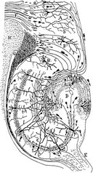

otherwise objects
in fraught domains of matter
unreal as algebra, empirical
in its desire for actual
made of math
in language

I’ll aufheben yr
Latinate
brain matter,

press my scruff-
weary cheek
against the mouth yr hippo-
campus feeds

*

Stesichorus 15

Like a living thing silent
and thirsty, the arrow bites
sharp through skin and
bone, to lodge vibrating
in the middle brain,
where it buries itself
to the feathers.

Geryon’s neck
slumps gently to one side
while the blood flows black
on gore-stained limbs
and breastplate:

a trickle of petals
at summer’s end,
the poppy’s tender
glory.

*

Dear Tomoko,
I have been so hesitant to send this to you. I’ve taken so long on it that I feel I shouldn’t send you anything unless it’s ultimately spectacular. I don’t know that I’ve accomplished that, but I do know that the analysis of the primary texts is (relatively) solid. I am still quite unsure about the theoretical framing. This paper has gone through so many stages in my thinking about it, and there is so much drafted material – from the last paper, to the rationale, to the new paradigms I’ve drafted – that choosing and editing has seemed overwhelming. I do hope you’ll take the first, framing section as a question-mark, and work with me to get something in place there that will fulfill the requirements for the incomplete. I have left out more than I can say, but need a guiding hand in deciding what should to be present, without the introduction devolving into chaos.
As to the Topics paper, the analysis of Ginsberg in this draft is drawn from a much larger body of drafted material. I’ve left out a significant amount of analysis of the Journals themselves, and the punch-line of the Topics paper, which is a relatively lengthy analysis of the return of a poetic speech of power in “Wichita Vortex Sutra”. The Topics paper is also in transition in terms of the theoretical perspective by means of which I frame it – I’m thinking more and more about questions of classical reception and supernatural speech acts, alongside questions of orientalism. I have also, in the meantime, and under the direction of Yopie, drafted what I believe will become another dissertation chapter on classical reception, supernatural language, and the poet Susan Howe’s Pythagorean Silence – which brings me to another point about our meeting: I had wanted to tell you in person, when we met, that I’ve asked Yopie to chair the committee. Your presence and insights have been extremely helpful in the preliminary exam process, especially in terms of carving out a theoretical space that would have been closed to a narrowly literary committee, and opening up a space to say things that might otherwise have been blocked. I also wanted to ask you if you wish to stay on the committee for the Topics paper process, and to express that I hope you will – even though I am well aware that I may have pressed patience beyond the limits of the rational Kantian public square, in my ridiculous delays concerning this draft.

